NAME: NISHA K

REG:NO: 192411231

**EXP:NO: 3**

Create a simple cloud software application for Property Buying &amp; Rental process (In Chennai city) using any Cloud Service Provider to demonstrate SaaS.

**AIM:**

To design and deploy a simple cloud-based Property Buying & Rental application (Chennai city) using Zoho Creator and demonstrate the concept of Software as a Service (SaaS).

**PROCEDURE:**

1. Log in to Zoho.com and access the Zoho Creator platform.
2. Create a new application and provide a suitable name (e.g., Chennai Property Buy & Rent Portal).
3. Design the application by adding necessary forms (Property details with location in Chennai, User registration, Rental/Buying request) and reports for data visualization.
4. Configure and deploy the application on the Zoho cloud platform.
5. Share the application link with users, enabling them to access the service directly via the internet.

**OUTPUT:**

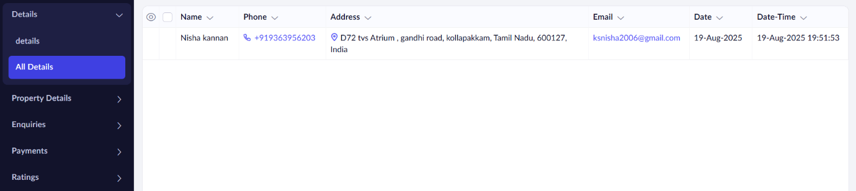

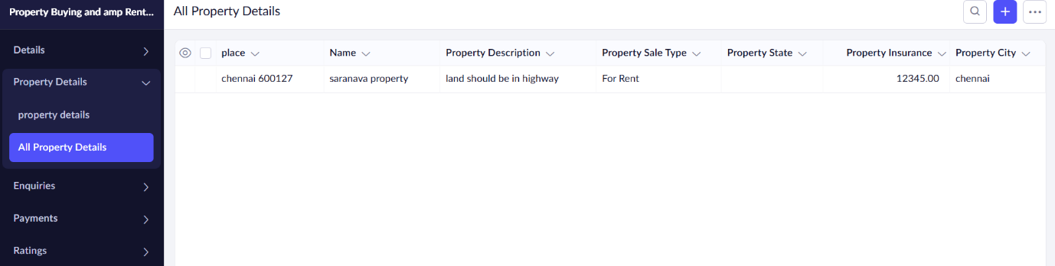

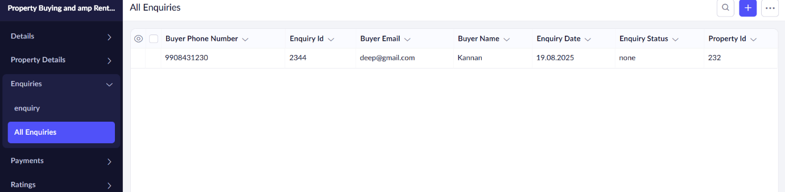

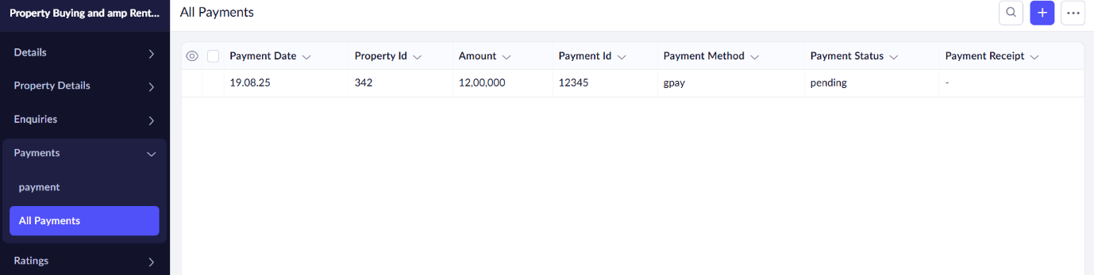

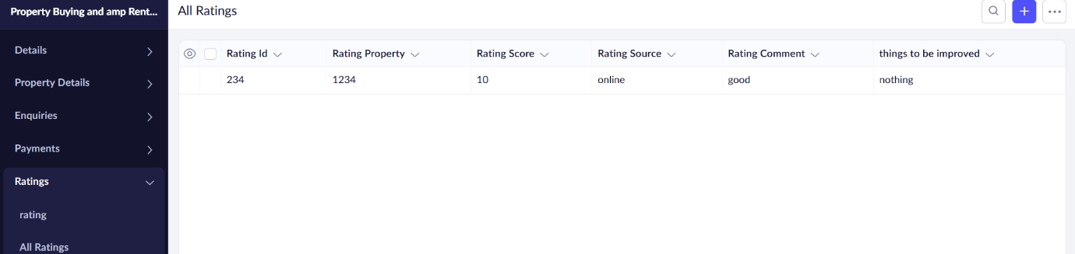

**RESULT:**

A Property Buying & Rental Application (Chennai city) was successfully created and deployed using Zoho Creator. Users can access the service online to register, list properties, and make rental/buying requests, thus demonstrating the SaaS model.

**Result**

A **Property Buying & Rental Application (Chennai city)** was successfully created and deployed using Zoho Creator.  
Users can access the service online to register, list properties, and make rental/buying requests, thus demonstrating the **SaaS model**.